Preliminary results to the manuscript in preparation:
Elevational patterns of plants‘ mating systems and pollen limitation in Afromontane grasslands

Authors:
Dominik Anýž (1), Štěpán Janeček (1), Carlson Bawe (?), Petr Chlup (1), Sylvain Delabye (1,4), Fernando Gaona (1,4), Jiří Hodeček (1,5), Petra Janečková (1,2), Ishmeal N. Kobe (1), Shedrach B. Kongvong (?), Francis E. Luma (?), Sailee Sakhalkar (1), Robert Tropek (1,4)
- Department of Ecology, Faculty of Science, Charles University, Viničná 7, 12843 Prague, Czechia
- Faculty of Science, University of South Bohemia, Branišovská 1760, 37005 České Budějovice, Czechia
- Faculty of Science, University of Buea, Cameroon
- Institute of Entomology, Biology Centre, Czech Academy of Science, České Budějovice
- Swiss Human Institute of Forensic Taphonomy, University Centre of Legal Medicine Lausanne-Geneva, Lausanne

Acknowledgements:
I would like to thank Robert Tropek for their supervision over my work. I would also like to thank the botanists, Štěpán Janeček and Petra Janečková, for their insight into the Cameroonian flora. I am thankful to Ishmeal N. Kobe who was responsible for overseeing the efficient completion of the second year of field study, and who along with Francis E. Luma harvested the mature fruits of our experimental species. Other members of the second-year expedition who I am grateful to are Peter K. Abigha, Francis T. Mani, Josef Ekema, Paul O. Agbor and Frederick B. Raboya. I am thankful to Shedrach B. Kongvong who helped me more than anyone in the field with my pollination experiments. I am thankful to Petr Chlup and Fernando Gaona for their assistance with the experiment in the field, and am grateful for the identification of insects by Jiří Hodeček and Sylvain Delabye. I would like to thank Sailee Sakhalkar for her help with the statistical analysis of the data.
This thesis was supported, within projects of my supervisor, by the Czech Science Foundation (20-16499S) and the Charles University (PRIMUS/17/SCI/8).

Project background:
Introduction
The aim of the study was to test whether various plants change their capability of producing more seeds through self-pollination with rising elevation in the grasslands of Mt. Cameroon.
Seven plant species were sampled in multiple elevations. Senecio purpureus and Lactuca inermis were sampled in four elevations, Crepis hypochoeridea and Hypericum revolutum were sampled in three elevations (2300, 2800, 4000 and 2800, 3500, 4000 respectively) and Clematis simensis, Geranium arabicum and Senecio burtonii were sampled in two elevations (2300,2800 and 2300,2800 and 2800,3500, respectively.
Each plant species was sampled in four elevations when possible*. The four treatments carried out on the plant species were autogamy (left in bag to self pollinate), geitonogamy (pollinated with flowers from the same individual), outcrossing (pollinated with flowers from a distant individual) and control (pollinated by pollinators).
The flowers were left to set seed and harvested one month after the experiments have been completed. The bags with the seeded flowers were brought to Czechia where the seeds were counted. All instances of flowers which had been “infested” with an insect, fell off during the experiment or were not properly labelled were dismissed from the analysis.
Along with the seedsets of each flowers we also have the following data: pollinator visitation data of individual plants from the elevations where they occurred, abundances of the plants in each elevation, nectar production of all the plants
Summary:
Four treatments:
Control (C), Outcrossing (O), Autogamy (O), Geitonogamy (G)
Four elevations:
2300, 2800, 3500, 4000
Seven species:
Clematis simensis (el. 2300, 2800), Crepis hypochoeridea (el. 2800, 3500, 4000), Geranium arabicum (el. 2300, 2800), Hypericum revolutum (el. 2300, 2800, 4000), Lactuca inermis (el. 2300, 2800, 3500, 4000), Senecio burtnoii (el. 2800, 3500), Senecio purpureus (el. 2300, 2800, 3500, 4000)
Four indexes:
Control (just individual seedsets), Pollen limitation ( PL = 1 – ( C / O) ), Autogamy ( A / O ), Geitonogamy ( G / O )

Preliminary results:
Index summary
The analysis shows that plants in elevation 2800 had the highest capability of producing seeds when left to be pollinated by visitors. Plants from elevations 2300 and 3500 similar amount of seeds (both lower than 2800) and plant in 4000 produced significantly fewer seeds than any of the lower elevations.
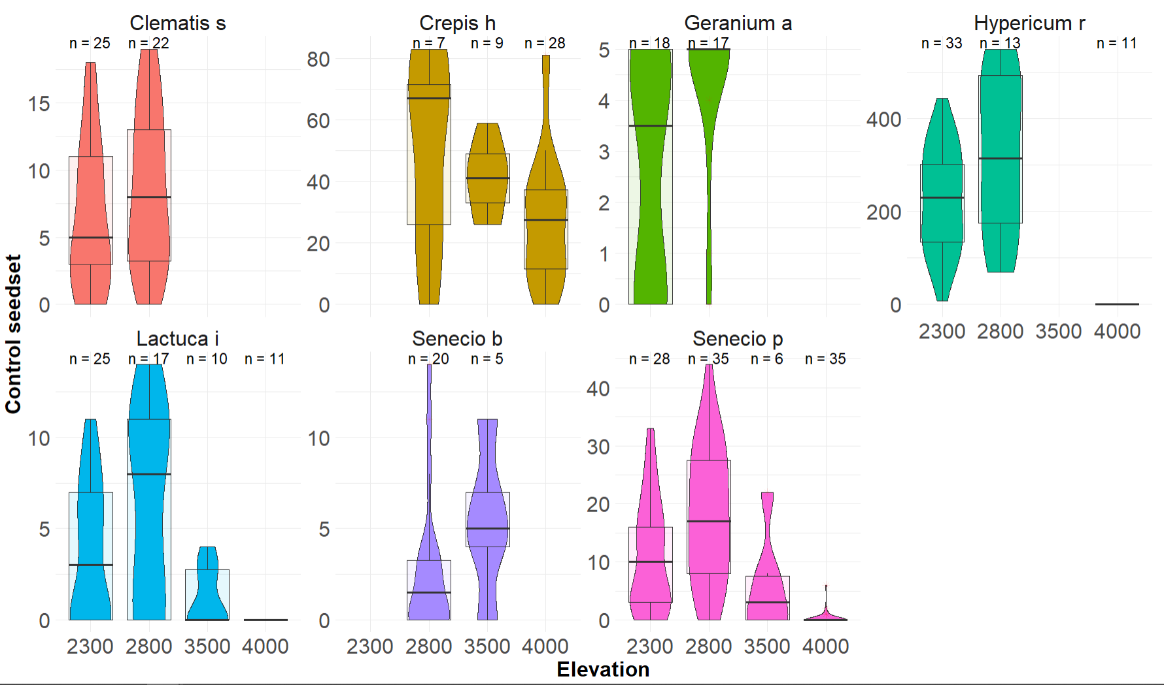
The only trend in pollen limitation was found in elevation 4000, which was significantly more pollen limited than the other elevations.
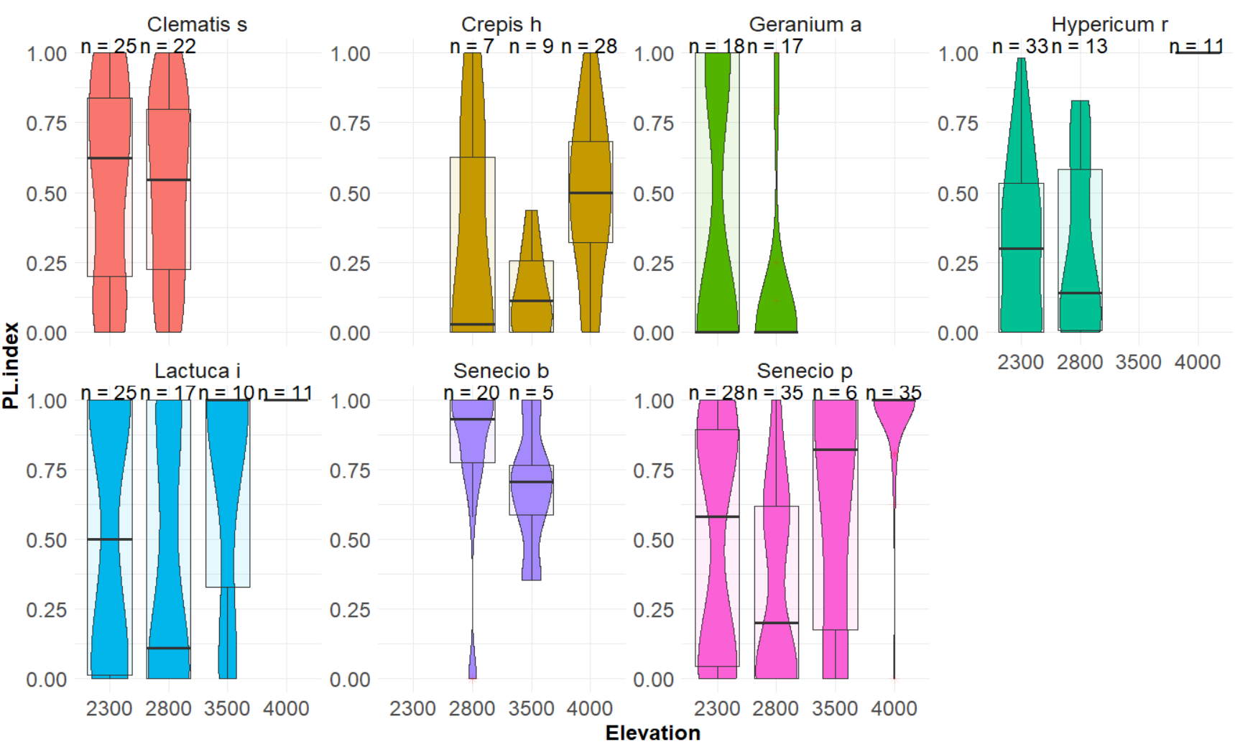
Autogamy was borderline significantly lower in elevation 4000 (p = 0.0974) that the intercept (elevation 2300), so there is a possibility that the highest elevation produced less seeds when plant were left to self pollinate than the lower elevation.
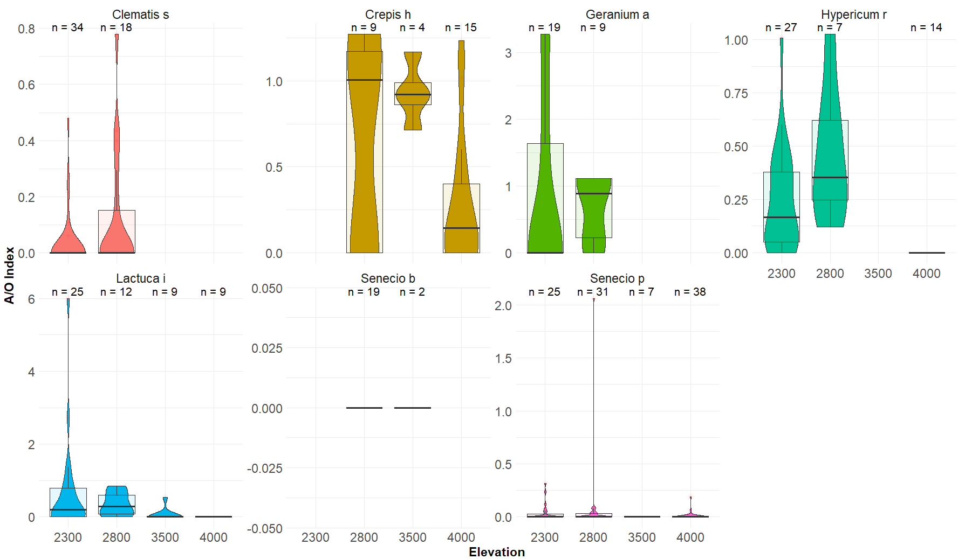
An opposite trend was observed in geitonogamy, where plants were observed to produce more seeds through geitonogamy in elevation 4000 when compared with elevation 2300 (p = 0.159), however we did have geitonogamy treatment from only two species in 4000 (Senecio purpureus and Crepis hypochoeridea) and so these results must be interpreted carefully.
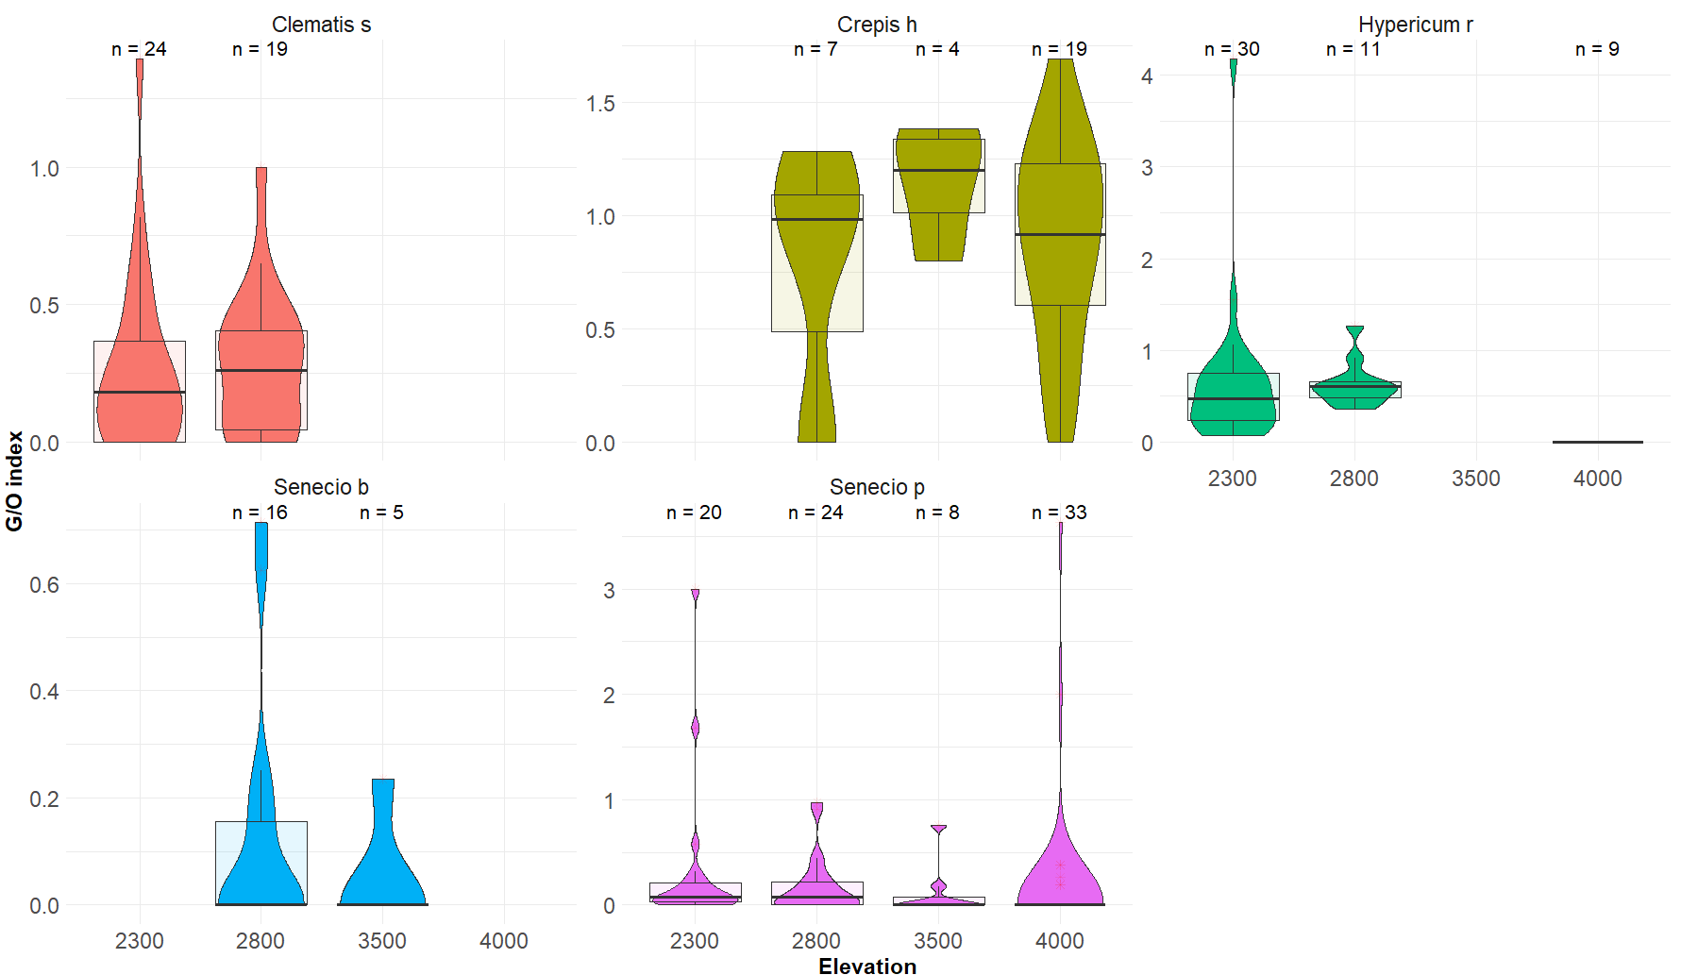
When looking at plants individually, it is possible to see that although self-pollination capability could have changed a bit over elevation, it certainly was not evident in most species.
Summary of visitation data
Visitation frequencies were highest in elevation 2800, although statistically only borderline significant (p = 0.0869) when compared with elevation 2300. This can be due to Hypericum, which had very high frequencies in 2800. Elevations 2800 and 3500 had comparable frequencies, of visitation. Elevation 4000 had significantly lower visitation frequencies than the lower three elevations (p = <2e – 16).
Species richness decreased from the lowest to the highest elevation. 2300 had 100 individual species, 2800 had 70, 3500 had 20 and 4000 had 17.
Comparing indexes with visitation data
So, we do see a correlation in seeds produced by the control treatment and visitation frequencies between elevations, however we do not see any correlation between control seed-sets and visitor species richness.
So, although elevation 2800 had only 75% of visitor species than elevation 2300, plants in 2800 produced statistically higher quantities of seeds. 2800 was borderline significant in terms of visitation frequencies when compared with 2300, however not when compared with 3500, or when 2300 and 3500 were compared. Overall, it seems that the decrease in visitor species richness from elevation 2300 to 3500 had little impact on the visitation frequencies of pollinators, which is also evident in the pollen limitation index, which is not significantly different for any of these elevations.
It is also evident, that even though elevation 3500 had much lower species diversity (20% of 2300, 30% of 2800), the visitation frequencies were proportionally quite high and thus plant species in this elevation were not pollen limited, unlike elevation 4000, where the drastic decrease of visitation frequencies led to severe pollen limitation.
What these results tell us is that in elevation 2300, 2800 and 3500, plants were not significantly more pollen limited between these elevations since the visitation frequencies were comparable, so the plants might not have been under selective pressure to become more capable of producing seeds through self-pollination. Elevation 4000 had low visitation frequencies of pollinators, leading to low seed-sets from the control treatment and severe pollen limitation, but even these plants did not prove to be capable of self-pollination than the rest.
This can be caused by the unfavorable condition, both biotic and abiotic, in elevation 4000. The conditions for the pollinators are so bad that their abundances are very low, and thus the conditions for pollen dispersal are sub-optimal. We could expect that this would lead to higher selfing rates in this elevation, however it is possible that the plants in these elevations do not reproduce properly since the conditions are so bad. It is also possible, that even if an adaptation to selfing were to happen, it could be diluted by seeds coming from the lower elevations and thus no selfing rates can be recorded.

